Review and Progress Open Access
Analysis of Treatment Methods and Techniques of Traditional Chinese Medicine
Lou Qiyan, Yang Yuchuan 
Zhejiang Yuankang Pharmaceutical Technology Co., Ltd., Zhuji, 311800, China
Corresponding author email: 1768126628@qq.com
International Journal of Clinical Case Reports 2023, Vol.13, No.5 doi: 10.5376/ijccr.2023.13.0005
Received: 14 Nov., 2023
Accepted: 15 Dec., 2023
Published: 28 Dec., 2023
Copyright © 2023 Lou and Yang, This is an open access article published under the terms of the Creative Commons Attribution License, which permits unrestricted use, distribution, and reproduction in any medium, provided the original work is properly cited.
Preferred citation for this article:
Lou Q.Y., and Yang Y.C., 2023, Analysis of treatment methods and techniques of traditional Chinese medicine, International Journal of Clinical Case Reports, 13(5): 1-9 (doi: 10.5376/ijccr.2023.13.0005)

Abstract As an important part of Chinese Traditional medicine, Chinese medicine, with its unique theoretical system, rich clinical experience, comprehensive treatment methods and technologies, has not only made important contributions to the health of the Chinese nation, but also made important contributions to the development of global medicine. The treatment methods and technologies of traditional Chinese medicine are an important part of the research of traditional Chinese medicine, including traditional Chinese medicine treatment, acupuncture and moxibustion, massage, medicine syndrome differentiation and treatment and other methods and technologies, and have achieved significant therapeutic effects in clinical practice and been widely used. This review will systematically review and analyze the treatment methods and technologies of traditional Chinese medicine, explore the application value and development prospects of traditional Chinese medicine treatment methods and technologies in clinical practice, and provide useful reference opinions for the development of traditional Chinese medicine.
Keywords Traditional Chinese medicine; Therapeutic method; Application analysis
Traditional Chinese medicine treatment is a traditional Chinese medical method, which not only has a profound cultural heritage, but also accumulates rich experience in clinical practice. The treatment methods of traditional Chinese medicine mainly include traditional Chinese medicine, acupuncture and moxibustion, massage and other treatments. Traditional Chinese medicine treatment, as an important component of traditional Chinese medicine, aims to prevent and treat diseases through its medicinal properties and efficacy. Acupuncture and moxibustion, as one of the characteristic therapies of traditional Chinese medicine, can regulate the balance of yin and yang, promote the circulation of qi and blood, and achieve the goal of treating diseases by stimulating the meridians and acupoints of the human body. Tuina can regulate various aspects of the human body, such as qi, blood, nerves, and muscles, through techniques such as massage, kneading, and massage, in order to achieve the goal of treating diseases.
Traditional Chinese medicine is a treasure of Chinese civilization, with a long history and a unique theoretical system. The treatment methods and techniques of traditional Chinese medicine are important aspects of traditional Chinese medicine research. These methods and techniques have been widely applied in clinical practice and have achieved significant therapeutic effects. They have rich connotations and broad application prospects, and have been continuously developed and improved through clinical practice, making important contributions to the treatment of diseases and the promotion of human health. Traditional Chinese medicine has unique advantages in clinical applications, such as being able to provide personalized diagnosis and treatments based on individual differences, regulating the overall state of the human body, rather than treating only a specific local symptom. Medicine syndrome differentiation and treatment is an important feature of traditional Chinese medicine treatment. Through comprehensive and detailed analysis and diagnosis of patients, personalized treatment plans are formulated to improve treatment effectiveness.
However, there are also some shortcomings in the clinical application of traditional Chinese medicine treatment methods, such as long treatment cycles and uncertain therapeutic time and so on. These issues need to be continuously explored and improved in future researches and clinical practice. The purpose of this review is to introduce the treatment methods of traditional Chinese medicine, as well as its clinical application and advantages. At the same time, it also explores the shortcomings of traditional Chinese medicine treatment methods and discusses how to address these issues for enhancement and refinement, aiming to better harness the therapeutic effects of traditional Chinese medicine. I hope to enable more people to understand the unique charm of traditional Chinese medicine treatment methods, promote the role of traditional Chinese medicine in clinical applications, and make greater contributions to people's health.
1 Common Methods of Traditional Chinese Medicine Treatment
1.1 Medical treatment
Medical treatment is one of the most commonly used methods in clinical practice of traditional Chinese medicine. Medical treatment is based on the theory of traditional Chinese medicine, which uses natural drugs such as Chinese herbal medicine to treat diseases. It has the advantages of significant therapeutic effect, small side effects, and comprehensive regulation. Medical treatment includes traditional Chinese medicine decoction pieces, traditional Chinese medicine injections, traditional Chinese medicine granules, capsules, etc.
Traditional Chinese medicine decoction pieces are one of the most commonly used and traditional dosage forms in traditional Chinese medicine treatment (Figure 1). It is to grind traditional Chinese medicine into powder, according to a certain proportion and formula, to make a certain amount of traditional Chinese medicine particles, and finally make a drink by boiling water or heating. Traditional Chinese medicine slices have the advantages of good taste, easy absorption, and easy portability, and are commonly used to treat common diseases such as colds, indigestion, and rheumatism. Traditional Chinese medicine injection is a method of injecting a solution made of traditional Chinese medicine into the body, through intravenous or intramuscular injection, to achieve the effect of treating diseases. Traditional Chinese medicine injections have the advantages of being fast, effective, and convenient, and are commonly used to treat acute and critically ill diseases. However, there are also some shortcomings, such as significant side effects and susceptibility to allergic reactions (Chan and Ng, 2020). Traditional Chinese medicine granules, capsules, and other dosage forms are made into granules, capsules, and other forms of traditional Chinese medicine, which are convenient for patients to take orally. Traditional Chinese medicine granules, capsules, and other dosage forms have the advantages of convenient administration, accurate dosage, and convenient storage, and are commonly used to treat digestive system diseases, gynecological diseases, and so on.
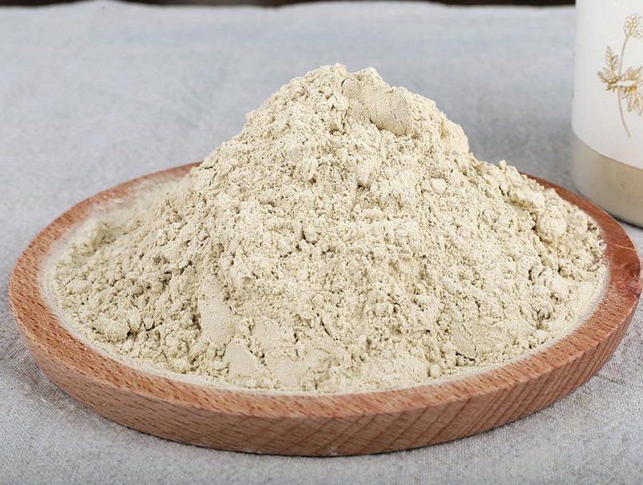
Figure 1 Chinese herbal slices (Image source: The New Bing)
Traditional Chinese medicine decoction pieces, traditional Chinese medicine injections, traditional Chinese medicine granules, capsules and other dosage forms are commonly used in traditional Chinese medicine treatment, with their own characteristics and indications. When using traditional Chinese medicine for treatment, suitable dosage forms and drugs should be selected based on the patient's condition and constitution to achieve the best treatment effect. At the same time, attention should also be paid to the side effects and adverse reactions of traditional Chinese medicine, and treatment should be carried out under the guidance of a doctor.
1.2 Acupuncture and moxibustion treatment
Acupuncture and moxibustion therapy has a history of thousands of years. It regulates qi and blood by needling human meridians or acupoints, achieving the effect of treating diseases and maintaining health. Acupuncture and moxibustion treatment is commonly used to treat pain, nervous system diseases, digestive system diseases, respiratory system diseases, etc. It is divided into meridian acupuncture and moxibustion, ear point acupuncture, and acupuncture and moxibustion methods such as pricking, collateral pricking, blood pricking, etc.
According to the meridian theory of traditional Chinese medicine, meridian acupuncture and moxibustion regulates qi and blood through acupuncture of human meridians to achieve the purpose of treating diseases. Meridian acupuncture and moxibustion is often used to treat various pains, digestive system diseases, respiratory system diseases, etc. Ear point acupuncture is a treatment method that regulates the function of various organs in the human body by needling specific acupoints on the ear. Ear point acupuncture has the advantages of simple operation and painless treatment in acupuncture and moxibustion, and is often used to treat various chronic diseases, quit smoking, lose weight, etc. Acupuncture and moxibustion and moxibustion methods such as pricking, collateral pricking and blood pricking are therapeutic methods that regulate the system of qi, blood, nerves, etc. of the human body by acupuncture at specific points, meridians or local nerves, muscles, etc. These acupuncture and moxibustion and moxibustion methods are often used to treat various pain, nervous system diseases, respiratory system diseases, etc.
When using acupuncture and moxibustion treatment, doctors need to select appropriate acupuncture and moxibustion methods and points according to the patient's condition and constitution to achieve the best therapeutic effect. At the same time, acupuncture and moxibustion treatment also needs to pay attention to the standardization and hygiene of acupuncture and moxibustion operation to avoid unnecessary risks.
1.3 Tuina massage therapy
Tuina massage therapy is a method of regulating qi and blood, activating meridians, muscles, and bones through massage and other techniques, in order to achieve the effects of treating diseases and health preservation. It is commonly used to treat pain, sports injuries, neurological diseases, etc., mainly in the forms of massage, cupping and scraping (Figure 2).
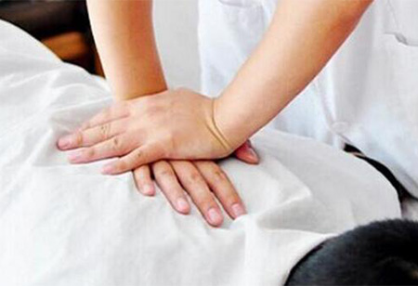
Figure 2 Tuina massage (Image source: The New Bing)
Tuina refers to a therapeutic method involving massage, kneading, and and manipulation of the body's meridians, tendons, bones, and organs using hands, aiming to regulate Qi and blood, relieve muscle tension, and promote metabolic functions. Tuina is commonly used to treat various types of pain, such as neck, shoulder, waist, and leg pain, etc. Massage refers to the treatment method of manually massaging the muscles, skin, etc. of the human body to regulate qi and blood, promote circulation, and alleviate fatigue. Massage is commonly used to treat sports injuries, muscle soreness, neurasthenia, etc. Cupping, scraping, and other techniques are treatment methods that use special instruments to scrape, adsorb, and promote the circulation of qi and blood, detoxify, and nourish the skin. Cupping, scraping and other techniques are commonly used to treat various types of pain, cervical spondylosis, colds, etc (Takayama and Iwasaki, 2016).
When using massage therapy, doctors need to choose suitable techniques and parts based on the patient's condition and physique to achieve the best treatment effect. At the same time, massage therapy also requires attention to the hygiene of instruments and techniques to avoid unnecessary risks.
1.4 Dietary therapy
Dietotherapy is one of the important means of traditional Chinese medicine treatment. It regulates the nutritional balance of the human body and the yin and yang of qi and blood through the selection and collocation of food to achieve the effect of disease treatment, health care and health preservation. It is often used to treat digestive system diseases, cardiovascular diseases, liver and kidney diseases, etc., mainly including Tonic Diet and nutrition conditioning (Zhao et al., 2021).
Dietary therapy with medicinal foods refers to the use of traditional chinese medicine ingredients to produce unique food, in order to achieve the treatment of disease and adjust the physique of the treatment method. Dietary therapy with medicinal foods has the effect of traditional Chinese medicine treatment, and is also a nutritious food, commonly used to treat liver and kidney diseases, cardiovascular diseases, etc. Nutritional conditioning refers to the treatment of diseases and health preservation by adjusting the nutritional balance of the human body through the selection and combination of food. Nutritional regulation is commonly used to treat digestive system diseases, liver and kidney diseases, etc.
When using dietary therapy, doctors need to choose suitable foods and combinations based on the patient's condition and constitution to achieve the best treatment effect. At the same time, dietary therapy also requires attention to the hygiene and safety of ingredients to avoid unnecessary risks.
2 Special Methods of Traditional Chinese Medicine Treatment
2.1 Traditional Chinese medicine syndrome differentiation and treatment
Traditional Chinese medicine syndrome differentiation and treatment is one of the core theories of traditional Chinese medicine, and it is an important feature of traditional Chinese medicine treatment. Medicine syndrome differentiation and treatment refers to the comprehensive and detailed analysis and diagnosis of a patient's condition through pulse, tongue examination, and inquiry of medical history, in order to develop personalized treatment plans and achieve the goal of treating the disease. The characteristic of traditional Chinese medicine syndrome differentiation and treatment is its emphasis on individualized treatment, targeting each individual's different situations. Traditional Chinese medicine syndrome differentiation and treatment emphasizes the analysis of etiology and pathogenesis, that is, the fundamental causes and mechanisms of treating diseases, rather than just treating symptoms.
Medicine syndrome differentiation and treatment also emphasizes "varying from person to person", which means developing personalized treatment plans based on different factors such as the patient's physique, age, and gender, in order to improve the treatment effect. The basic principle of traditional Chinese medicine syndrome differentiation and treatment is to distinguish different syndromes of the condition and adopting corresponding treatment methods for different syndromes. Traditional Chinese medicine divides the condition into "syndrome" and "disease". "Syndrome" refers to the manifestation of the condition, while "disease" refers to the essence of the condition. Through syndrome differentiation and treatment, traditional Chinese medicine can treat different syndromes and the essence of different conditions (Cheung et al., 2021).

Traditional Chinese medicine syndrome differentiation and treatment is an important feature of traditional Chinese medicine treatment. Through comprehensive and detailed analysis and diagnosis of patients, personalized treatment plans are formulated to improve treatment effectiveness. The purpose of traditional Chinese medicine syndrome differentiation and treatment is to treat diseases and improve the quality of life of patients, which is one of the core theories of traditional Chinese medicine in clinical application.
2.2 Qigong therapy
Qigong therapy is a very special method in traditional Chinese medicine treatment, which adjusts the body's qi field and promotes the circulation of qi and blood by adjusting breathing, vocalization, body posture, etc., achieving the effect of treating diseases and maintaining health. It is commonly used to treat cardiovascular diseases, respiratory diseases, neurological diseases, etc.
The basic principle of Qigong therapy is to regulate and improve the physiological, psychological, immune and other functions of the human body by adjusting and enhancing the body's qi field. It mainly includes various methods such as sitting and nourishing qi, qigong conditioning, qigong massage, etc. Among them, sitting and nourishing qi is the most common method. By sitting quietly and nourishing qi, one can adjust breathing, relax the body, concentrate, and improve the body's immune function, regulate the body's endocrine system, lower blood pressure, and achieve the goal of treating diseases. It does not require special venues and equipment, and does not require special physical strength and skills. Breathing technique therapy can also improve the body's self-healing ability, by regulating and enhancing the body's qi field, promoting physical health and immune enhancement, thereby achieving the goal of preventing and treating diseases.
Qigong technique therapy is a non-pharmacological, non-surgical, and side effect free treatment method that can prevent and treat many diseases and has broad application value. The advantages of Qigong therapy are its simple and convenient operation, which can improve the body's self-healing ability (Feng et al., 2006).
2.3 Psychotherapy
Psychotherapy is another method of traditional Chinese medicine treatment, which regulates the emotions and psychological states of patients through methods such as psychotherapy, cognitive behavioral therapy, music therapy, and art therapy, achieving the effect of treating diseases and alleviating symptoms. It is commonly used to treat depression, anxiety, and neurasthenia,etc.
The basic principle of psychotherapy is to help patients understand their psychological problems and the causes of mental disorders through methods such as psychological counseling, hypnosis, and cognitive behavioral therapy, etc., recognize their psychological characteristics and behavioral patterns, and provide targeted treatment. Psychotherapy emphasizes the patient's initiative and self-regulation ability. By establishing a good therapeutic relationship, patients can explore and change themselves in a safe and protective environment, gain a deep understanding of their psychological problems and mental disorders. Through multiple methods of treatment, it is highly targeted and has significant therapeutic effects. It can help patients solve many psychological problems, such as depression, anxiety, fear, obsessive-compulsive disorder, etc., and has a significant effect on improving patients' quality of life and promoting physical and mental health. However, the therapeutic effect of psychotherapy is also influenced by various factors, such as the patient's treatment attitude and the professional level of the therapist (Zhang et al., 2019).
Psychotherapy is a people-oriented, psychological based treatment method that has significant therapeutic effects and broad application prospects. The advantage of psychotherapy is that it can provide a deep understanding of the patient's psychological problems and disorders, and can be treated through various methods. It is highly targeted and has significant therapeutic effects, but it also requires reasonable use and operation.

3 Application Fields of Traditional Chinese Medicine Treatment Methods and Technologies
3.1 Treatment of common diseases
Traditional Chinese medicine is often used to treat many common diseases, such as colds, coughs, diarrhea, hemorrhoids, gastritis, insomnia, etc. For these illnesses, traditional Chinese medicine can employ treatment methods such as herbal medicine, acupuncture, and massage based on the patient's symptoms, constitution, medical history, and other factors, aiming to achieve therapeutic effects.
A cold is an upper respiratory tract infection caused by a viral infection, and common symptoms include runny nose, sneezing, and sore throat. For mild colds, traditional Chinese medicine often treats them with traditional Chinese medicine decoction, such as Mahuang decoction, Guizhi decoction, etc; For severe colds, traditional Chinese medicine injections such as heat-clearing and detoxifying injection and isatis root injection can be used for treatment. At the same time, traditional Chinese medicine can also help treat colds through acupuncture and moxibustion, moxibustion and other treatments. Cough is a symptom caused by factors such as infection and allergies, and common symptoms include coughing, expectoration, etc. For acute cough, traditional Chinese medicine often treats it with traditional Chinese medicine decoction (Figure 3), such as Chuanbei Pipa Ointment, Gouqizi zhi Gancao decoction, etc; For chronic cough, traditional Chinese medicine conditioning, acupuncture and moxibustion and other treatment methods can be used as auxiliary treatment. Diarrhea is a symptom caused by factors such as infection and food poisoning, and common symptoms include diarrhea, abdominal pain, etc. For mild diarrhea, traditional Chinese medicine often uses traditional Chinese medicine decoction, such as Huanglianejiao decoction, Shengyiyiren decoction, etc; For severe diarrhea, traditional Chinese medicine injections such as berberine injection and Changyanning injection can be used for treatment. At the same time, Chinese medicine can also assist in the treatment of diarrhea through acupuncture and moxibustion, massage and other treatments.
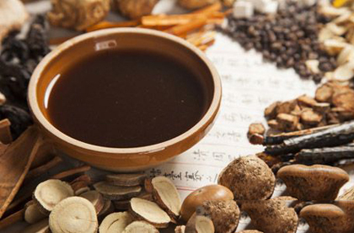
Figure 3 Traditional Chinese medicine decoction (Image source: The New Bing)
The treatment methods of traditional Chinese medicine include traditional Chinese medicine, acupuncture and moxibustion, massage and other treatment methods. The key to treatment is to treat according to medicine syndrome differentiation and treatment, and individualized treatment is carried out according to the patient's symptoms, physique, medical history and other conditions. Meanwhile, during the treatment process, patients also need to pay attention to adjustments in diet, rest, and other aspects, and cooperate with doctors for treatment in order to achieve the best treatment effect.
3.2 Treatment of chronic diseases
Traditional Chinese medicine is also commonly used to treat many chronic diseases, such as hypertension, diabetes, coronary heart disease, rheumatoid arthritis, etc. For these diseases, traditional Chinese medicine can adopt the method of medicine syndrome differentiation and treatment, using Chinese medicinal materials, acupuncture and moxibustion and other treatment methods to adjust the balance of yin and yang in the human body, so as to achieve the effect of treating diseases and alleviating symptoms (Wang et al., 2015).
Hypertension is a chronic disease caused by various factors, with common symptoms including headache, dizziness, palpitations, etc. For patients with hypertension, traditional Chinese medicine often uses traditional Chinese medicine, acupuncture and moxibustion and other treatment methods for treatment. The commonly used Chinese medicines are Tianma Gouteng decoction, Baiziren pill, etc. The commonly used acupuncture and moxibustion treatment methods include the stimulation of Fengchi, Neiguan and other acupoints. At the same time, traditional Chinese medicine also emphasizes the adjustment of patients' diet, lifestyle habits, and other aspects to achieve the effect of treating hypertension. Diabetes is a disease caused by insufficient insulin secretion or poor insulin function. Common symptoms include polydipsia, polyuria, thirst, etc. For patients with diabetes, traditional Chinese medicine often uses traditional Chinese medicine, acupuncture and moxibustion and other treatment methods for treatment. The commonly used traditional Chinese medicines include Shenfu capsule, hypoglycemic tea, etc. The commonly used acupuncture and moxibustion treatment methods include the stimulation of Zusanli, Guanyuan and other acupoints (Sun et al., 2016). Meanwhile, Chinese medicine also emphasizes the adjustment of patients' diet, exercise and other aspects to achieve the effect of treating diabetes. Coronary heart disease is a disease caused by coronary artery stenosis or blockage, and common symptoms include chest tightness, palpitations, shortness of breath, etc. For patients with coronary heart disease, traditional Chinese medicine often uses traditional Chinese medicine, acupuncture and moxibustion and other treatment methods for treatment. The commonly used traditional Chinese medicines include Danshen Tablets, Astragalus, etc. The commonly used acupuncture and moxibustion treatment methods include the stimulation of Xinshu, Neiguan and other acupoints. At the same time, traditional Chinese medicine also emphasizes the adjustment of patients' diet, exercise, and other aspects to achieve the effect of treating coronary heart disease.
For patients with chronic diseases, regular follow-up and treatment are also very important, which can help patients control their condition and reduce its progression.
3.3 Preventive care
Traditional Chinese medicine can also be used for prevention and health care. Traditional Chinese medicine believes that the health of the human body needs to maintain a balance of yin and yang. Treatment methods such as traditional Chinese medicine and Qigong can regulate the balance of yin and yang in the human body, achieving the effect of health preservation. For example, Qigong can help the human body regulate breathing, relieve stress, enhance immunity, and prevent the occurrence of diseases.
Diet is an important link in disease prevention, and traditional Chinese medicine emphasizes dietary regulation (Figure 4). Traditional Chinese medicine believes that the human body needs five nutrients, namely carbohydrates, proteins, fats, vitamins, and minerals. Reasonably matching diet and ensuring balanced intake of nutrients can enhance human immunity and prevent the occurrence of diseases. Appropriate exercise can enhance the body's immune system and prevent the occurrence of diseases. The recommended exercise methods for traditional Chinese medicine include Tai Chi, Qigong, Wuqinxi, etc. These exercise methods balance the functions of physical exercise and psychological regulation. Sleep is an important way for the human body to recover and regulate. Traditional Chinese medicine believes that good sleep can enhance the body's immune system and prevent the occurrence of diseases. Adults are advised to maintain at least 7 hours of sleep per day. Psychological health care is an important link in preventing diseases. Traditional Chinese medicine believes that emotions are one of the factors that affect human health, and positive emotions can enhance the body's immune system and prevent the occurrence of diseases. It is recommended that people learn to regulate their emotions reasonably and maintain a happy mood. The environment is the foundation of human survival, and a good environment can prevent the occurrence of diseases. It is recommended that people pay attention to environmental hygiene, maintain indoor air circulation, and prevent the harm of pollutants.
The methods of traditional Chinese medicine prevention and health care include multiple aspects such as dietary regulation, exercise health care, sleep health care, psychological health care, and environmental health care, etc. Traditional Chinese medicine focuses on comprehensive and personalized prevention and health care, improving the body's disease resistance and preventing the occurrence of diseases through various methods such as reasonable diet, appropriate exercise, good sleep, positive emotions, and a good environment. At the same time, traditional Chinese medicine also advocates for people to pay attention to self-care, detect and handle health problems early, and maintain physical and mental health (Qi et al., 2015; Liao et al., 2017).
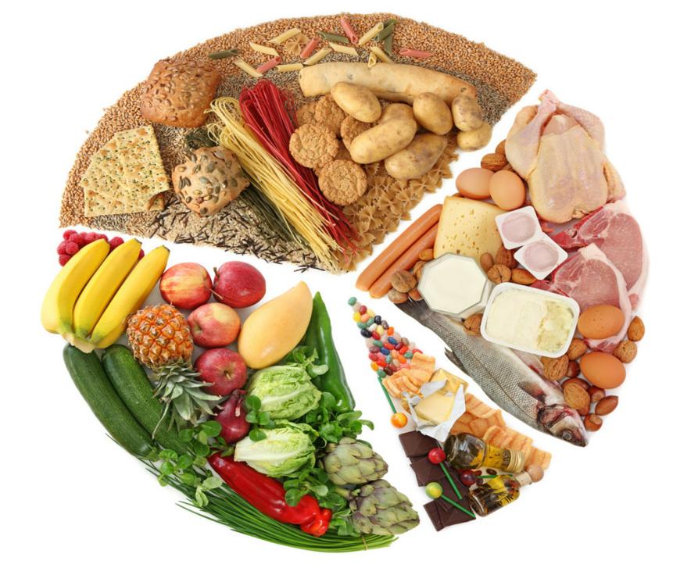
Figure 4 Dietetic regulation (Image source: The New Bing)
4 Summary and Outlook
As an important component of the excellent cultural tradition of the Chinese nation, the rich clinical experience and unique theoretical system of traditional Chinese medicine have made significant contributions to the health cause of the Chinese nation. As an important aspect of traditional Chinese medicine research, traditional Chinese medicine treatment methods and techniques have the characteristics of diversification, personalization, and integration, and have achieved significant therapeutic effects in clinical practice. The treatment methods and technologies of traditional Chinese medicine include acupuncture and moxibustion, massage, traditional Chinese medicine treatment, Qigong therapy, medicine syndrome differentiation and treatment and other methods and technologies. These methods and technologies have achieved significant therapeutic effects in clinical practice, and have obvious advantages and application values in the medical field. The application of traditional Chinese medicine treatment methods and technologies can reduce the amount and side effects of drugs, reduce medical costs, and improve overall treatment effectiveness, thus making important contributions to the development of modern medicine.
Traditional Chinese medicine treatment methods and technologies have been widely applied and recognized in the field of modern medicine, becoming an important auxiliary treatment method. But at the same time, there are also some problems and difficulties, such as the theoretical system still needs to be improved, and the standardization and standardization of clinical applications still need to be further strengthened. The future treatment methods and technologies of traditional Chinese medicine need to be further improved and improved, including strengthening the research and application of traditional Chinese medicine treatment methods and technologies, promoting the standardization, standardization, and modernization process of traditional Chinese medicine, improving the scientific and effective nature of traditional Chinese medicine treatment methods and technologies, and making greater contributions to human health.
With the development of science and technology, the treatment methods and technologies of traditional Chinese medicine are also constantly innovating and developing. For example, researches on traditional Chinese medicine microcapsule technology, rational compatibility of traditional Chinese medicine, and material basis of traditional Chinese medicine efficacy have provided new ideas and methods for the development of traditional Chinese medicine. In addition, acupuncture and moxibustion, massage, Qigong and other treatments are also constantly innovating and improving, providing new technical support for the development of traditional Chinese medicine. Strengthening the scientific research and promotion of traditional Chinese medicine can enhance the awareness of traditional Chinese medicine among the general public, promote its clinical application and preventive health effects. At the same time, strengthening the quality supervision and standardized management of traditional Chinese medicine, improving the safety and effectiveness of traditional Chinese medicine, is also an important direction for the development of traditional Chinese medicine.
Acknowledgments
Thanks to Ms. Jin Lingfei for her professional feedback after reading the manuscript.
References
Chan H.H.L., and Ng T., 2020, Traditional Chinese medicine (TCM) and allergic diseases, Curr. Allergy Asthm. R., 20: 67.
https://doi.org/10.1007/s11882-020-00959-9
Cheung H., Doughty H., Hinsley A., Hsu E., Lee T.M., Milner-Gulland E.J., Possingham H.P., and Biggs D., 2021, Understanding Traditional Chinese Medicine to strengthen conservation outcomes, People and Nature, 3(1): 115-128.
https://doi.org/10.1002/pan3.10166
Feng Y., Wu Z.H., Zhou X.Z., Zhou Z.M., and Fan W.Y., 2006, Knowledge discovery in traditional Chinese medicine: state of the art and perspectives, Artif. Intell. Med., 38(3): 219-236.
https://doi.org/10.1016/j.artmed.2006.07.005
Liao Y.H., Li C.I., Lin C.C., Lin J.G., Chiang J.H., and Li T.C., 2017, Traditional Chinese medicine as adjunctive therapy improves the long-term survival of lung cancer patients, J.Cancer Res. Clin., 143: 2425-2435.
https://doi.org/10.1007/s00432-017-2491-6
Qi F.H., Zhao L., Zhou A.Y., Zhang B., Li A.Y., Wang Z.X., and Han J.Q., 2015, The advantages of using traditional Chinese medicine as an adjunctive therapy in the whole course of cancer treatment instead of only terminal stage of cancer, Biosci. Trends, 9(1): 16-34.
https://doi.org/10.5582/bst.2015.01019
Sun G.D., Li C.Y., Cui W.P., Guo Q.Y., Dong C.Q., Zou H.B., Liu S.J., Dong W.P., and Miao L.N., 2016, Review of herbal traditional Chinese medicine for the treatment of diabetic nephropathy, J. Diabetes Res., 10:5749857.
https://doi.org/10.1155/2016/5749857
Takayama S., and Iwasaki K., 2016, Systematic review of traditional Chinese medicine for geriatrics, Geriatr. Gerontol., 17(5): 679-688.
https://doi.org/10.1111/ggi.12803
Wang H.F., Zhang H.L., Li J.S., Yu X.Q., Li S.Y., Li B., Xie Y., and Bai Y.P., 2015, Effectiveness and safety of traditional Chinese medicine on stable chronic obstructive pulmonary disease: a systematic review and meta-analysis, Complement. Ther. Med., 23(4): 603-611.
https://doi.org/10.1016/j.ctim.2015.06.015
Zhang W.Y., and Cheng Y.C., 2019, Challenge and prospect of traditional Chinese medicine in depression treatment, Front. Neurosci., 13:190.
https://doi.org/10.3389/fnins.2019.00190
Zhao X.Y., Tan X.G., Shi H.F., and Xia D.Z., 2021, Nutrition and traditional Chinese medicine (TCM): a system’s theoretical perspective, Eur. J Clin. Nutr., 75: 267-273.
https://doi.org/10.1038/s41430-020-00737-w

